

**MEMORANDUM OF UNDERSTANDING**

This is a document validating an agreement between **MR. OGABOR JOHN AND MR. OLOLANI BADMUS** for the collaborative of 20% interest over a sum of **THREE HUNDRED AND TWENTY THOUSAND NAIRA ONLY (₦320,000) paid on the 06th of June, 2020.**

There is a binding agreement to pay the initial capital invested, alongside the interest, **THREE HUNDRED AND EIGHTY FOUR THOUSAND NAIRA ONLY (₦384,000) on the 06th of July, 2020** by **MR. OGABOR JOHN TO MR. OLOLANI BADMUS.**

Attached with this document is an evidence of payment by **MR. OLOLANI BADMUS.**

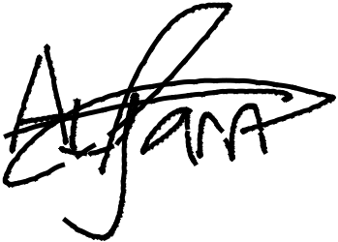

_________________________

_~~__~~_____~~___~~_~~_~~___________



**MR. OLOLANI BADMUS**

**MR. OGABOR JOHN**

***(CEO, JOHN INVESTMENTS)***